Phase1 Project

Task 1,2,3,4) Jira Epic, Story and Spring Created.

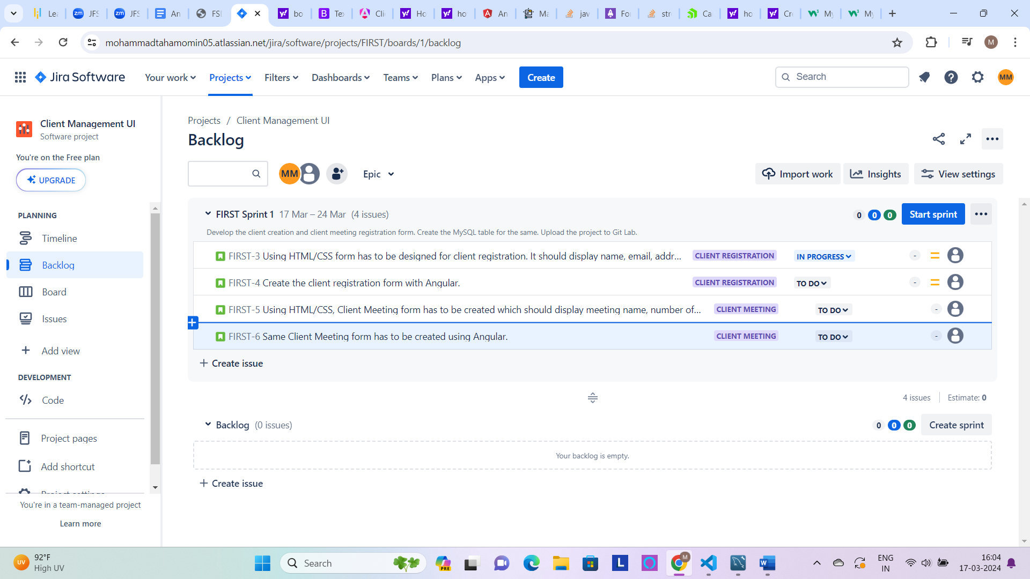

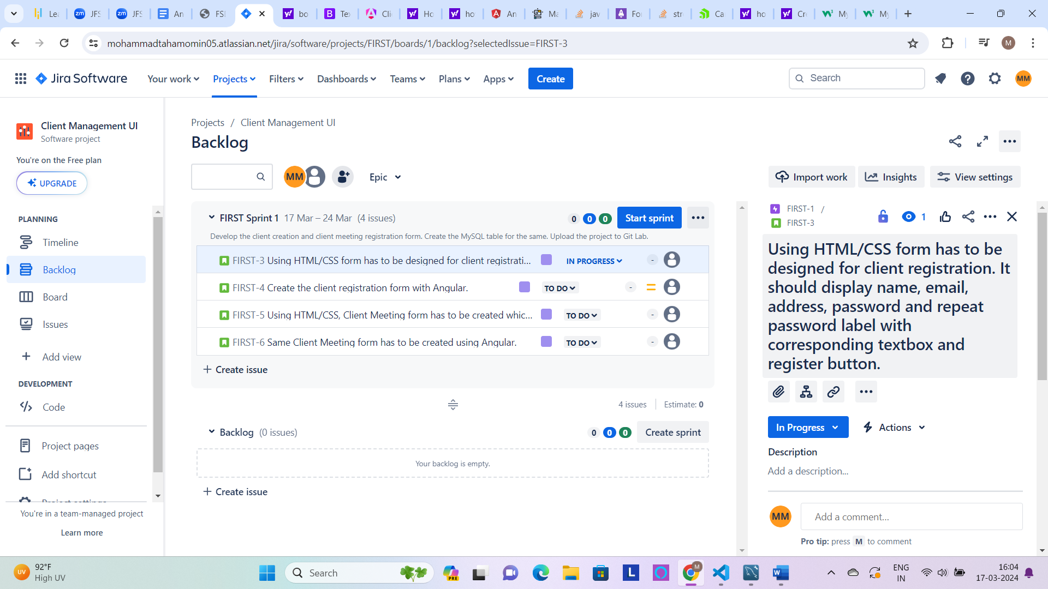

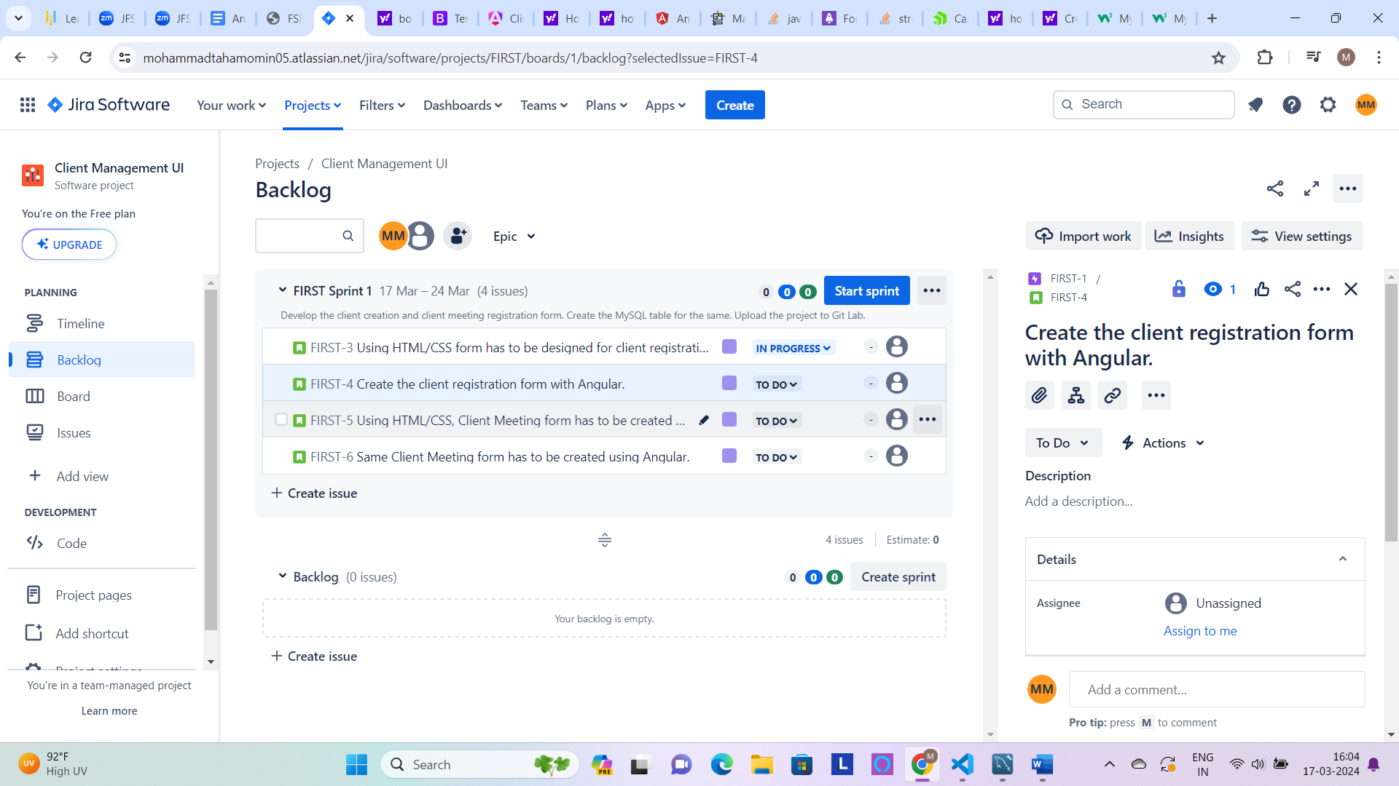

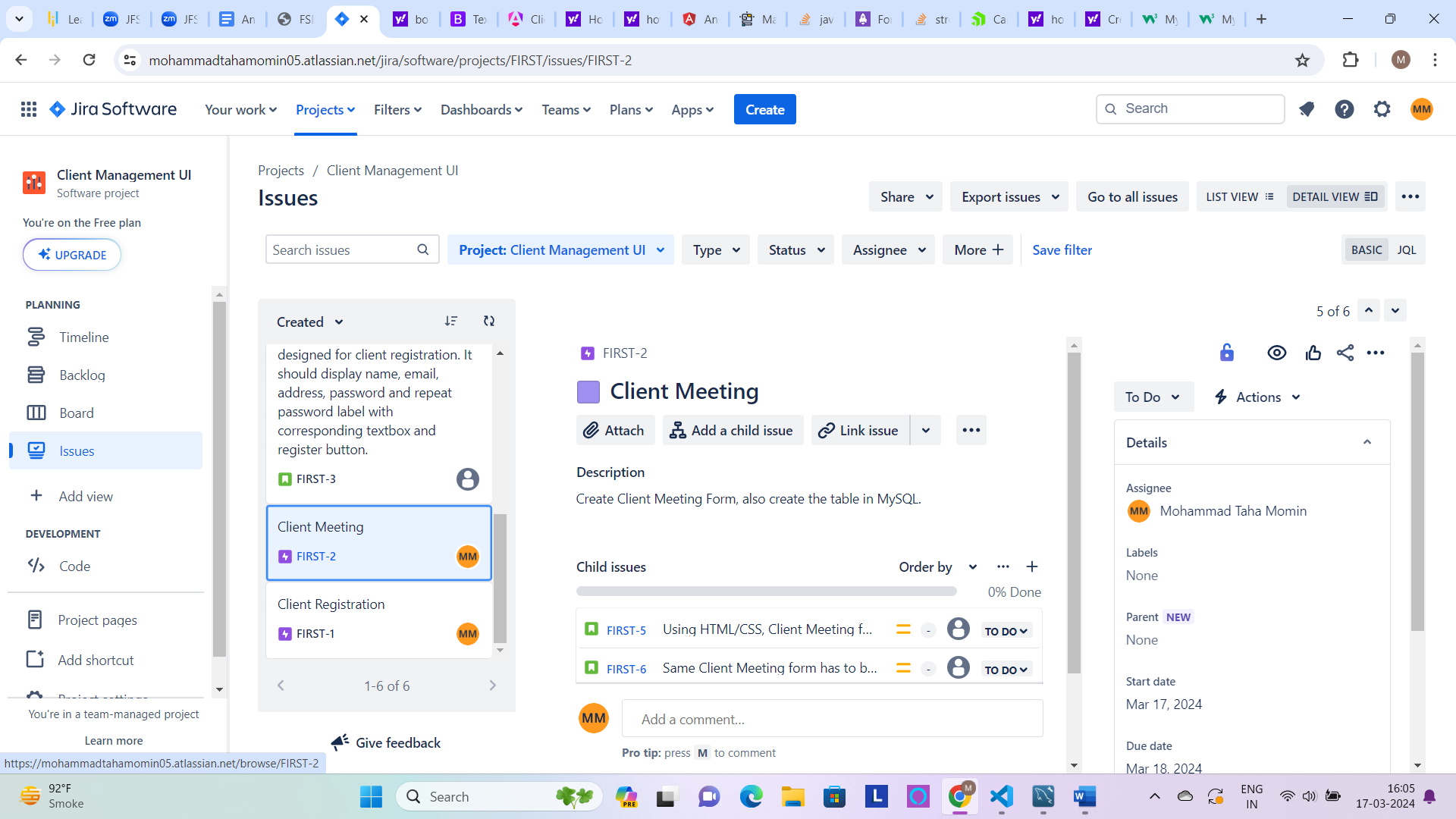

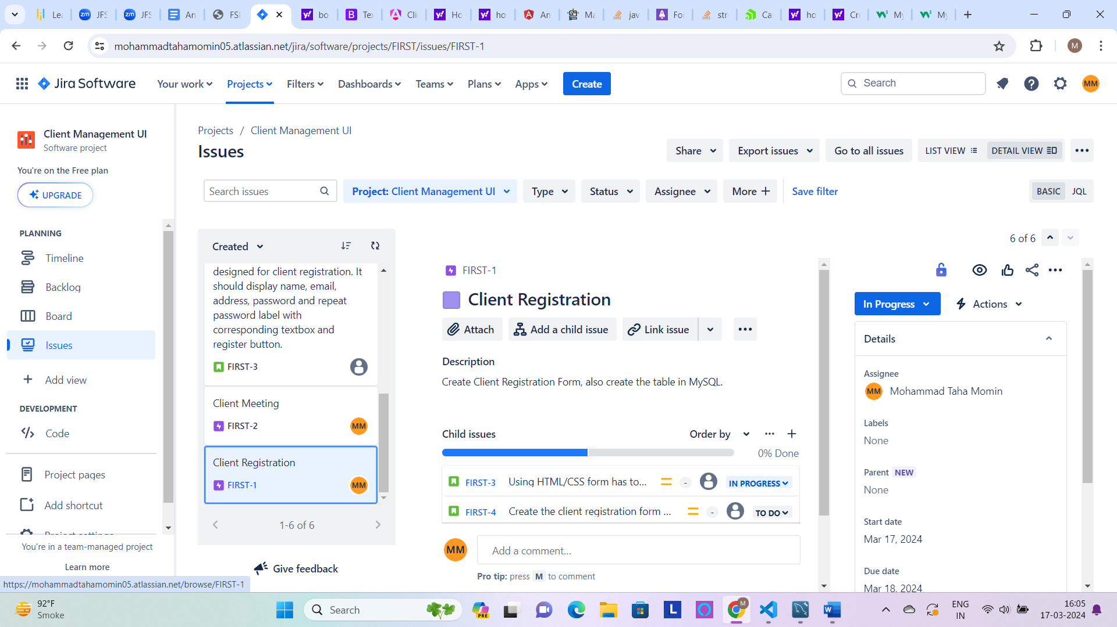

5) HTML Code and output

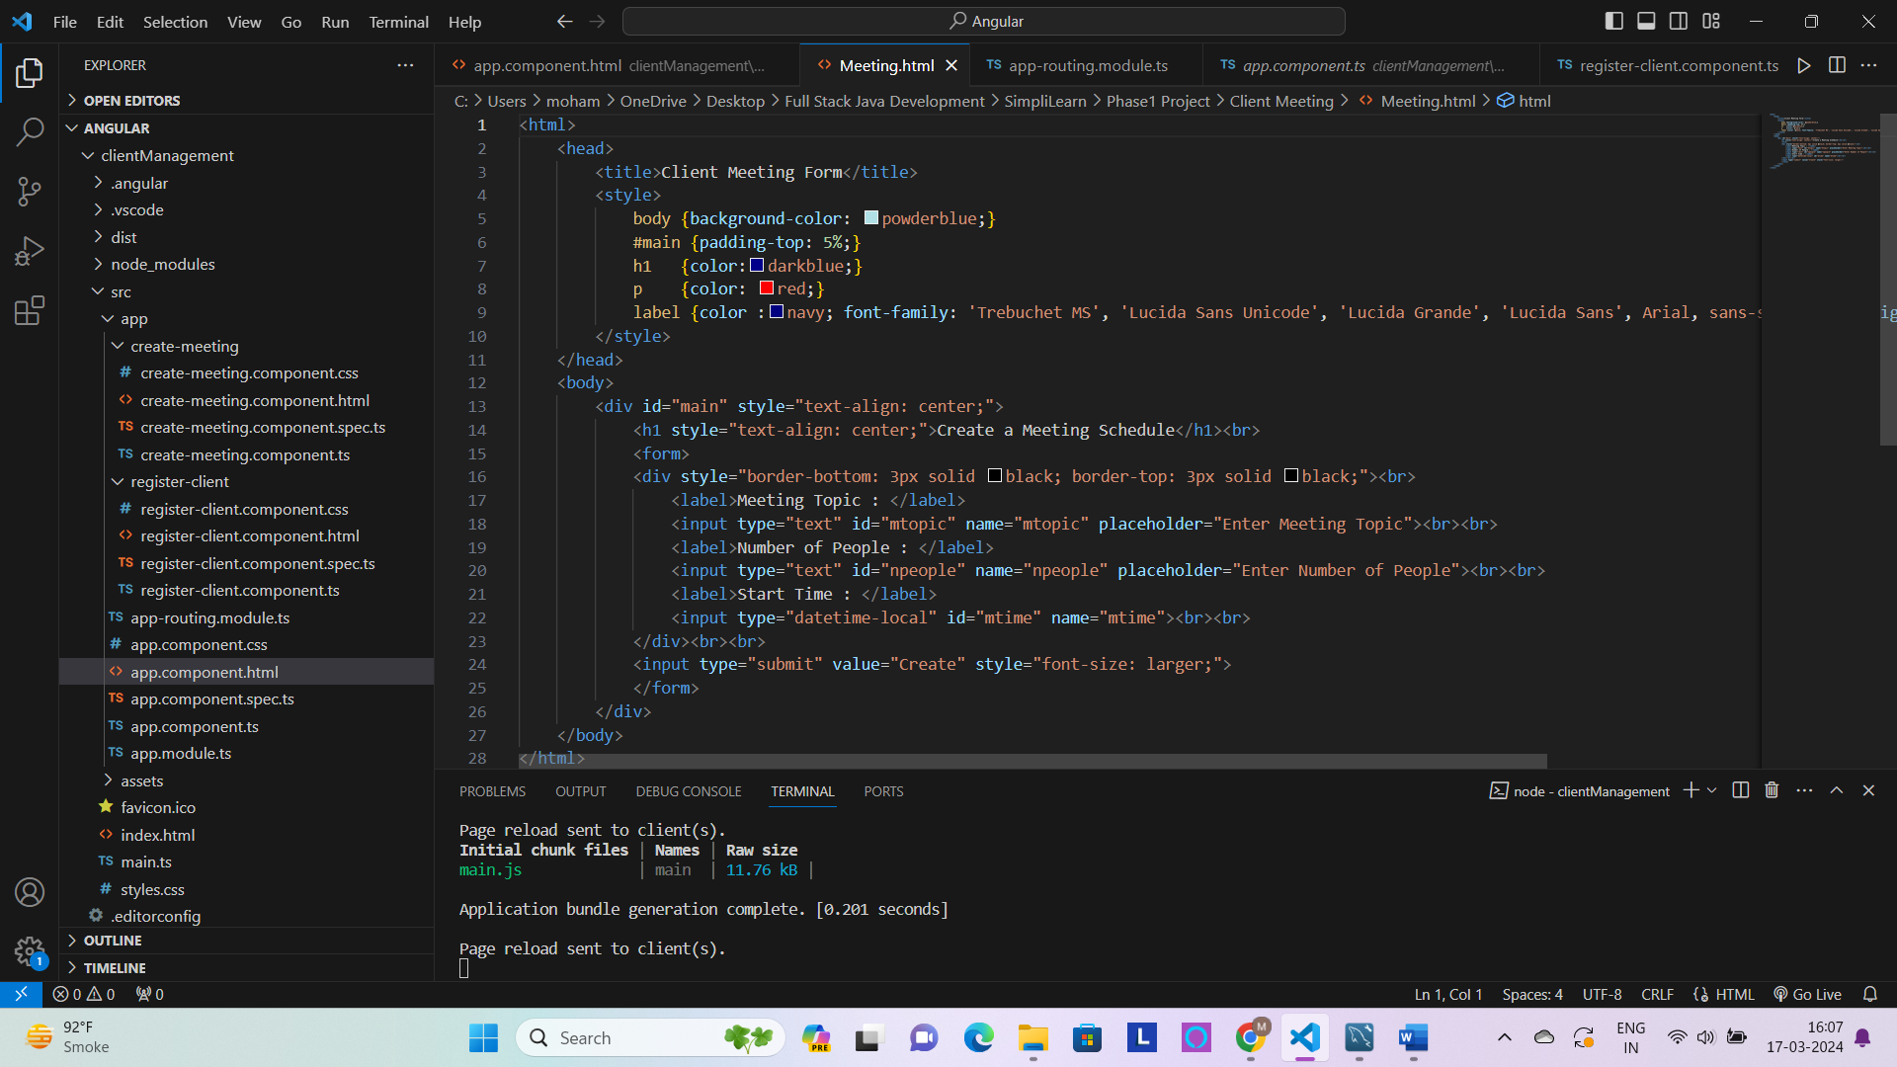

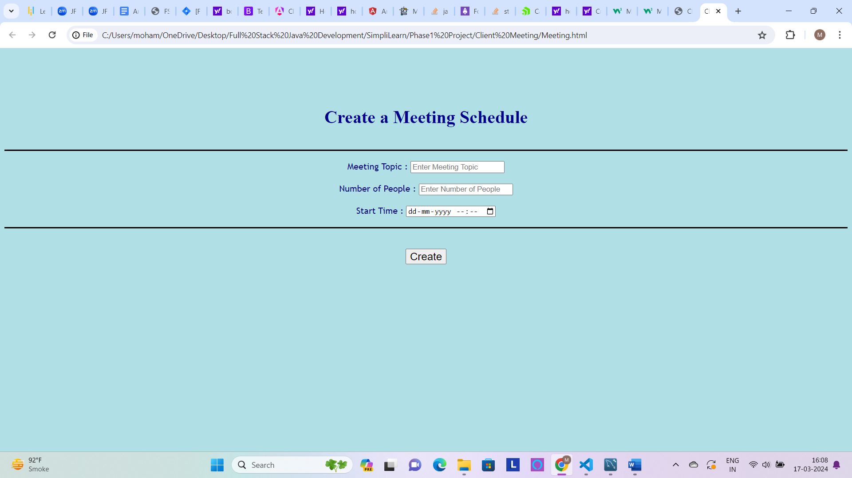

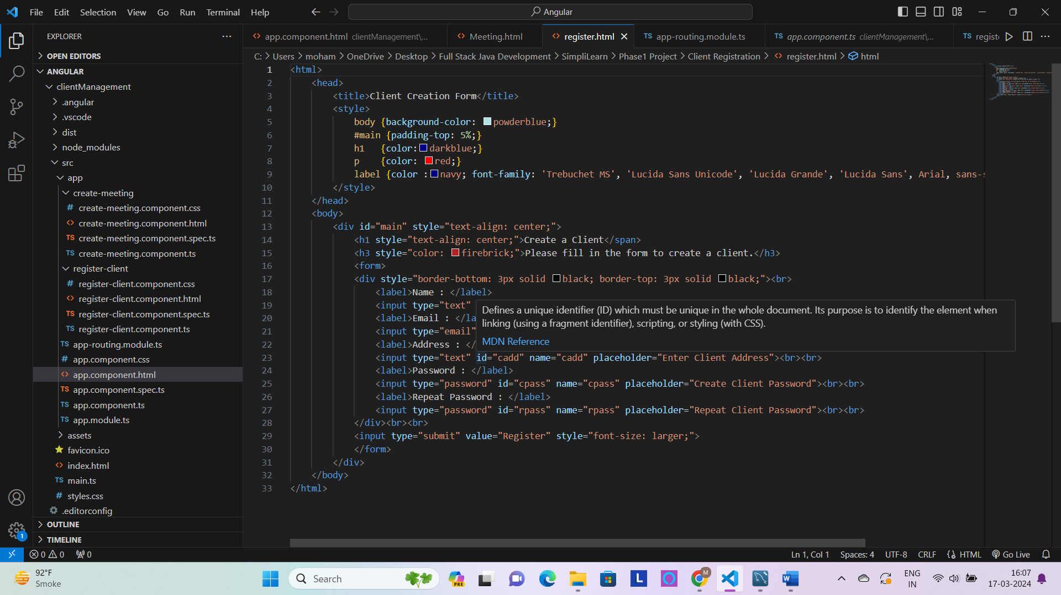

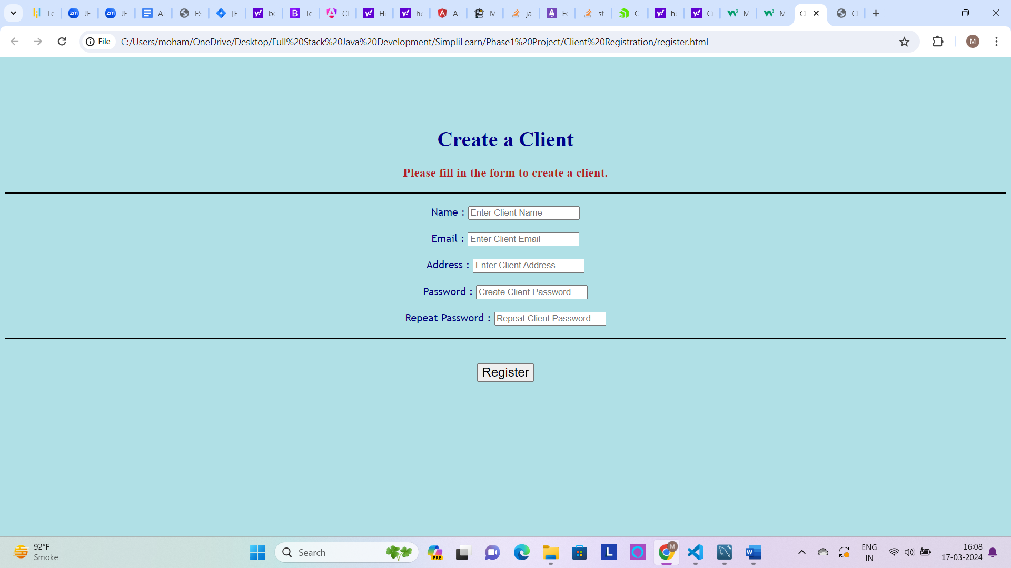

6) Angular output:

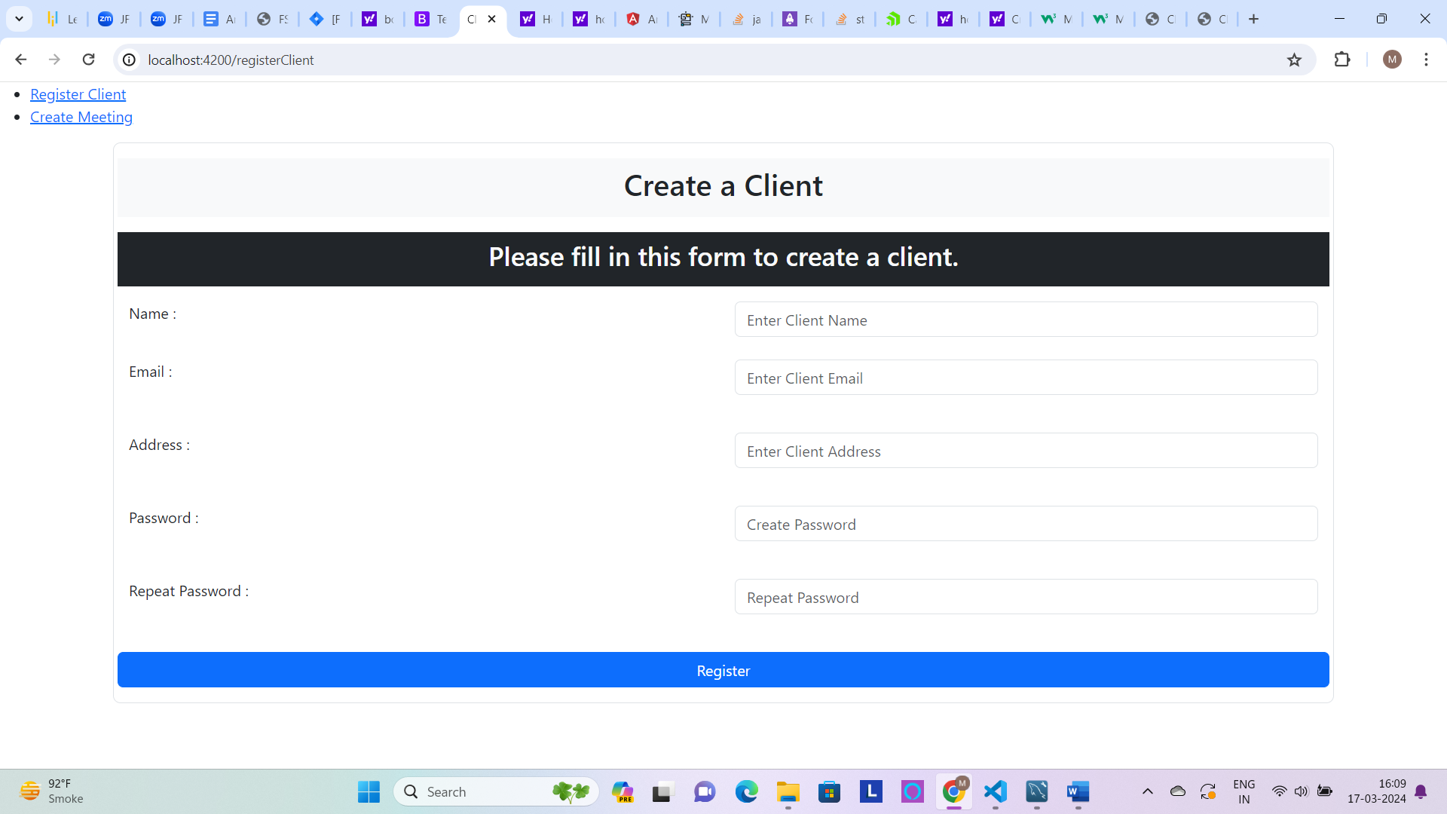

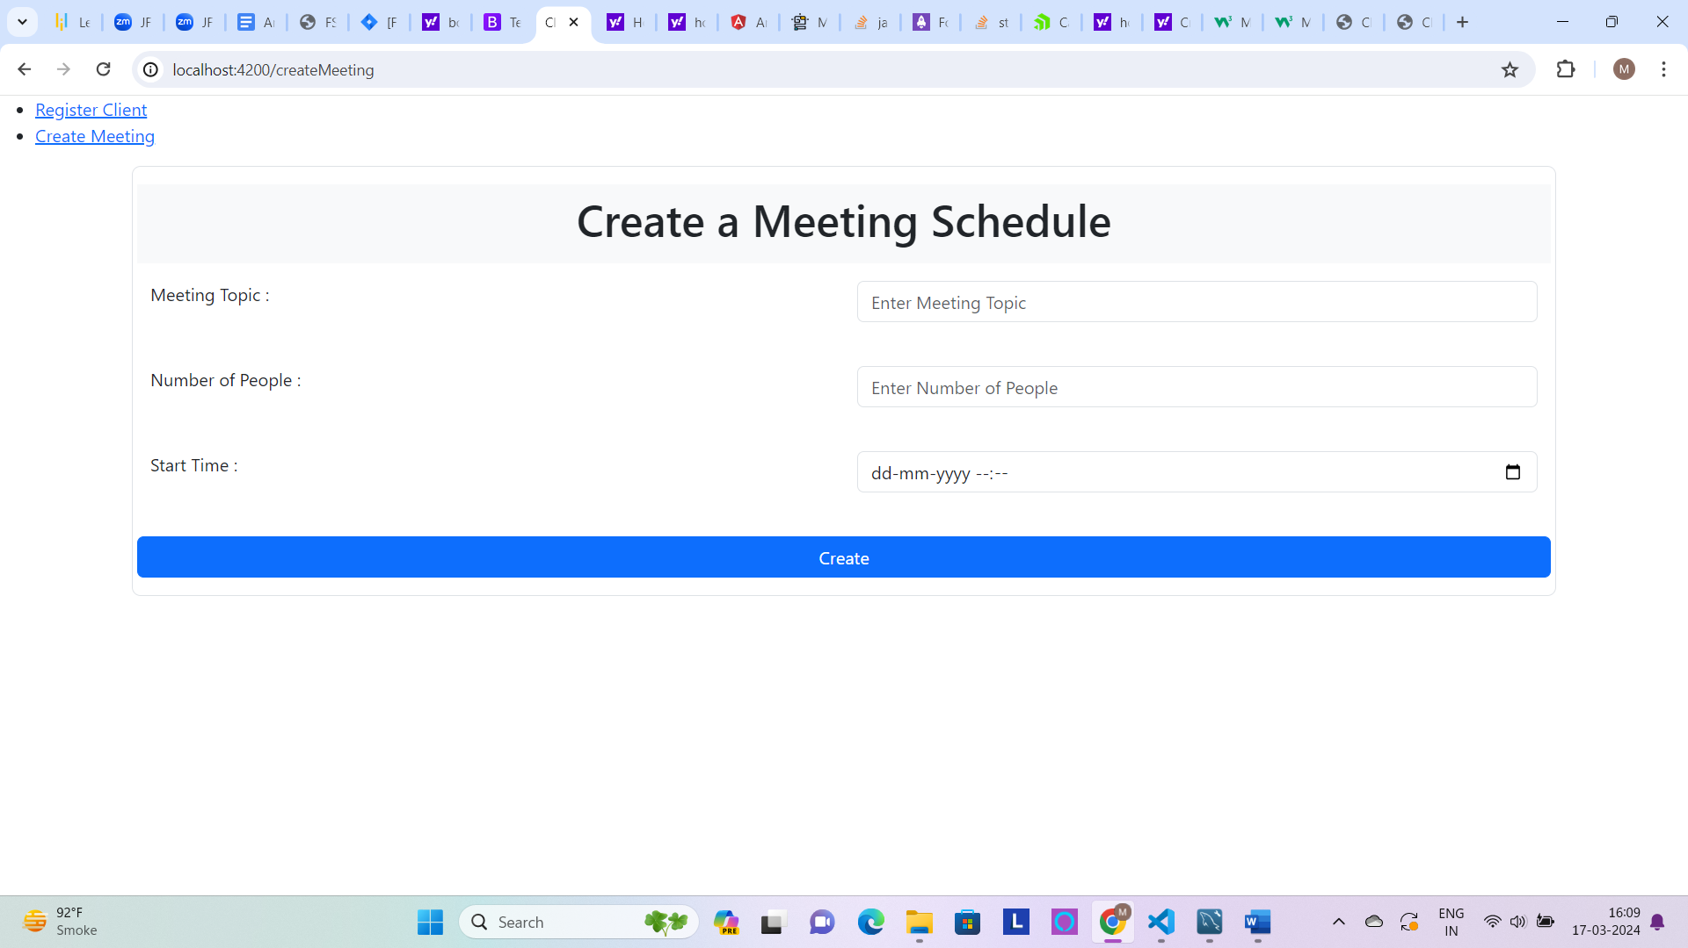

Code is present in the github link :

<https://github.com/tahamomin-05/ClientManagement/tree/main>

7) MySQL tables creation

Create DATABASE clientmanagement;

use clientmanagement;

create table CLIENT (

Id Int NOT NULL,

Name varchar(50),

Email varchar(100),

Address varchar(255),

password varchar(255),

PRIMARY KEY (id)

);

Create Table Meetings (

topic varchar(255) NOT NULL,

noOfPeople int,

startTime datetime,

PRIMARY KEY (topic)

);